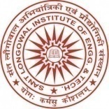 | SantLongowal Institute of Engineering & Technology  (Deemed-to-be-University)  Longowal, Distt. Sangrur, Punjab-148106
 | Institute Innovation Cell (IIC)

Title of the Project |  |  | Project ID  P-2022-
List of Major Components: | Faculty Advisors: | Student’s Team:
Total Expenditure Incurred
Unique Value Proposition
Summary:

